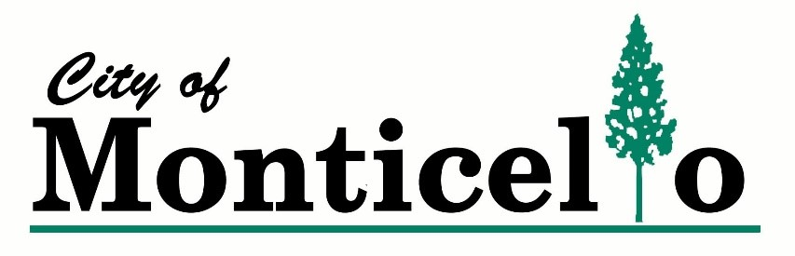
PICKUP OF GOODS
ONLY on Friday

For pickup of your white goods (stove, refrigerator, washer, dryer, etc.) or tires. Pickup fees
will be added to your utility bill as a miscellaneous charge. Return this form to City Hall at
123 West Washington Street, Monticello, GA. 31064 in person, by mail or by placing in the night
deposit box located on the side of the building in the alley.
---------------------------------------------------------------------------------------------------------------------

DATE: _____________

ITEMS TO PICK UP
→ WHITE GOODS…………… $10.00
→ CAR TIRES………………… $10.00 per tire
→ TRUCK TIRES……………... $15.00 per tire
→ TRACTOR TIRES…………. $20.00 per tire
→ OTHER ____________________________________________________________________________________________________________________________________________________________

NAME as listed ON UTILITY BILL: ____________________________________________
ACCOUNT NUMBER ON UTILITY BILL: ______________________________________
ADDRESS: ________________________________________________________________
PHONE NUMBER: _________________________________________________________
I understand this charge will be added to my utility bill as a miscellaneous charge.
Signed: __________________________________________________________________

